Worksheet 6

Student Name:Aryan Tomar UID:25MCI10167
Branch:MCA (AI&ML) Section/Group:1/A
Semester:2nd Date of Performance:01/03/2026
Subject Name:- DBMS LAB Subject Code: 25CAP-652

1. Aim of the Session

Learn how to create, query, and manage views in SQL to simplify database queries and provide a layer of abstraction for end-users.

2. Software Requirements
- PostgreSQL (Database Server)
- pgAdmin
- Windows Operating System

3. Objective of the Session
- Data Abstraction: To understand how to hide complex table joins and calculations behind a simple virtual table interface.
- Enhanced Security: To learn how to restrict user access to sensitive columns by providing views instead of direct table access.
- Query Simplification: To master the creation of views that pre-join multiple tables, making reporting easier for non-technical users.
- View Management: To understand the syntax for creating, altering, and dropping views, as well as the naming conventions required for efficient data access.

4. Practical / Experiment Steps

Prerequisite Understanding

• Students should first understand that a View is a virtual table created from a SELECT query and does not store data physically.

• Students should understand the difference between base tables (which store data) and views (which display data dynamically from base tables).

• Students should create at least two related tables (for example, Employee and Department) to demonstrate simple and complex view creation.

• The base tables should contain:
• A unique identifier (Primary Key)
• Related columns for establishing relationships (Foreign Key)
• Descriptive attributes such as name, salary, or status

• Students should understand the concept of JOIN operations before creating multi-table views.

• Students should understand aggregate functions (COUNT, SUM, AVG) for creating summarized views.

• Students should be familiar with basic SQL commands including:
• CREATE VIEW
• SELECT
• CREATE OR REPLACE VIEW
• DROP VIEW

• Students should understand that views can be used as a security layer by granting access to the view instead of the original tables.

5. Procedure of the Practical

(i) Start the system and log in to the computer.

(ii) Open PostgreSQL software.

iii) Create and select the database.

Create database Practical6;

(iv) Create table using DDL command.

create table department (

dept_id serial primary key,

dept_name varchar(50)

);

create table employee (

emp_id serial primary key,

emp_name varchar(50),

salary numeric(10,2),

status varchar(20),

dept_id int references department(dept_id)

);

(v) Insert records into the table.

insert into department (dept_name) values

('HR'),

('IT'),

('Finance'),

('Sales');

insert into employee (emp_name, salary, status, dept_id) values

('Rahul', 40000, 'Active', 1),

('Ankit', 52000, 'Active', 2),

('Priya', 60000, 'Inactive', 2),

('Neha', 35000, 'Active', 3),

('Aman', 70000, 'Active', 4);

(vi) Display all records.

select * from employee;

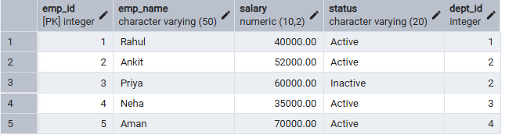

select * from department;

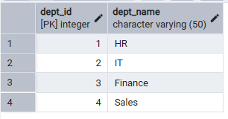

Step 1: Creating a Simple View for Data Filtering

create view active_employees as

select emp_id, emp_name, salary, dept_id

from employee

where status = 'Active';

select * from active_employees;
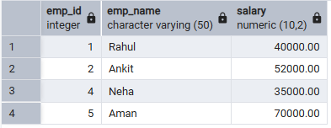
Step 2: Creating a View for Joining Multiple Tables
create view employee_department_view as
select
e.emp_id,
e.emp_name,
e.salary,
d.dept_name
from employee e
join department d
on e.dept_id = d.dept_id;

select * from employee_department_view;

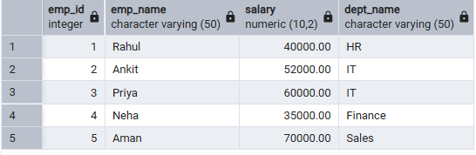

Step 3: Advanced Summarization View
create view department_summary as
select
d.dept_name,
count(e.emp_id) as total_employees,
avg(e.salary) as average_salary,
sum(e.salary) as total_salary
from department d
left join employee e
on d.dept_id = e.dept_id
group by d.dept_name;

select * from department_summary;

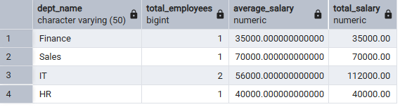

create or replace view active_employees as
select emp_id, emp_name, salary
from employee
where status = 'Active';

select * from active_employees;
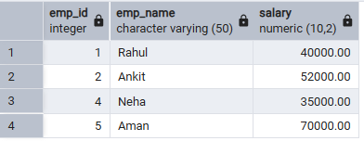

6. I/O Analysis (Input / Output)
Input:
• Creation of base tables such as Employee and Department
• Insertion of sample records into base tables
• SQL queries used to create simple and complex views
• JOIN operations applied within view definitions
• Aggregate functions (COUNT, SUM, AVG) used in summary views
Output:
• Virtual tables (Views) created successfully without storing physical data
• Filtered employee data displayed through simple views
• Combined employee-department data retrieved using JOIN-based views
• Department-level statistical summaries generated automatically
• Simplified query results for reporting purposes
• Secure and controlled data access provided through view-based permissions
• Real-time updated results when underlying base tables are modified
Screenshots of execution and obtained results are attached.
7. Learning Outcomes
- Abstraction Proficiency: Students will be able to create and query views to simplify efficient data access and abstraction.
- Security Implementation: Students will understand how to use views for data masking and providing restricted access to sensitive information.
- Syntactic Accuracy: Students will demonstrate the correct syntax for creating and querying views, ensuring logical clarity in naming conventions.
- Real-world Application: Students will be able to design views for practical domains like Library Management Systems or Payroll Systems to demonstrate functionality.

